**GO-SHIP 2018 S04P, NBP 18-02 Sunday April 1, 2018**

**Week 3** **– Start of 67°S Sampling and Transit South to 150°W**

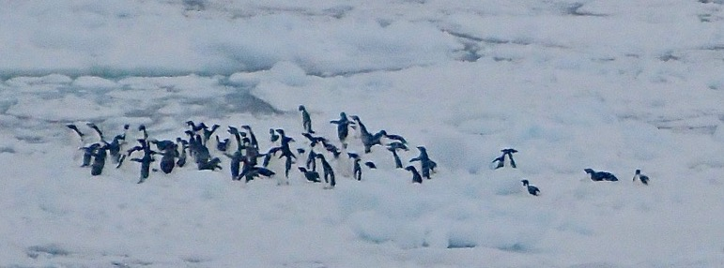

Conference concerning the pros and cons of running away from the orange giant

J. Brower

Current position: 73° 51’S, 152° 8’W

Winds: from SW at 13 knots

Outside Temp: -10.3°C, 13.5°F

Wind Chill: -27°C, -16.6°F

Surface Water Temp: -1.61°C, 29.1°F

Heading for ice edge at ~150°W

After last week’s report, we received a number of requests for a map. The one below tells the story of our expedition thus far. The green dots, beginning off Cape Adare near 70°S are our stations 1-8. By station 8, a series of storms had put a hold on our work, so we dove south of the worst of the weather to the ice edge at 170°W. We moved northward up the 170°W line sampling every 30 nm, i.e. 55 km (red dots), then went back to where we had left off sampling along 67°S (blue dots).

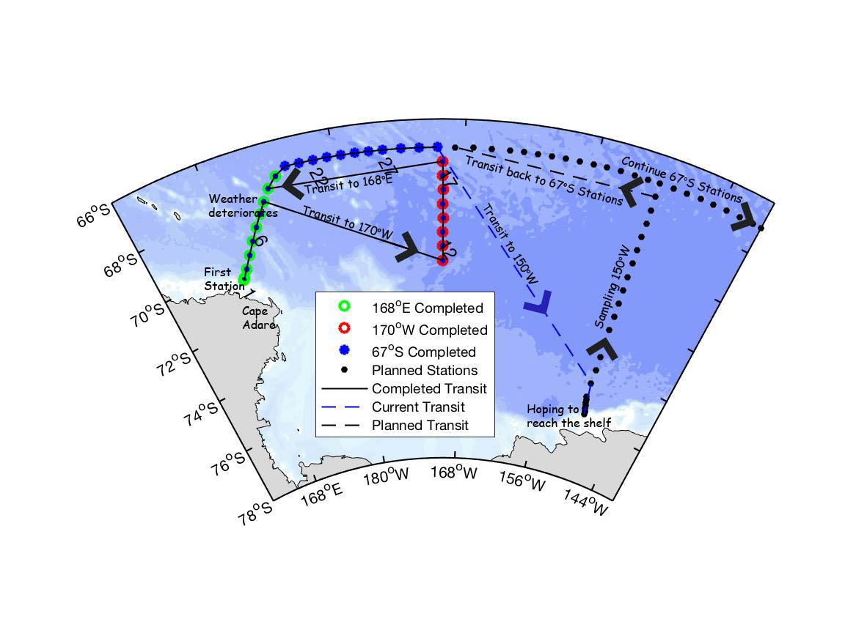

2018 S04P NBP-1802

Black numbers indicate stations

Along the way we have deployed 8 GDP drifters, 3 SOCCOM biogeochemical floats, 4 FSU ALTO floats and 1 CSIRO APEX floats. The SOCCOM floats have been adopted by schools and named. The ones deployed so far are Fall River Elementary’s Floating Falcon (mentioned in last week’s report), Monte Vista Elementary’s Super Seal (shown below on the left), and the UBC/McGill Thunderbird-Martlet (shown below on the right).

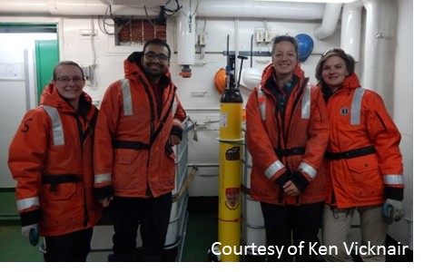

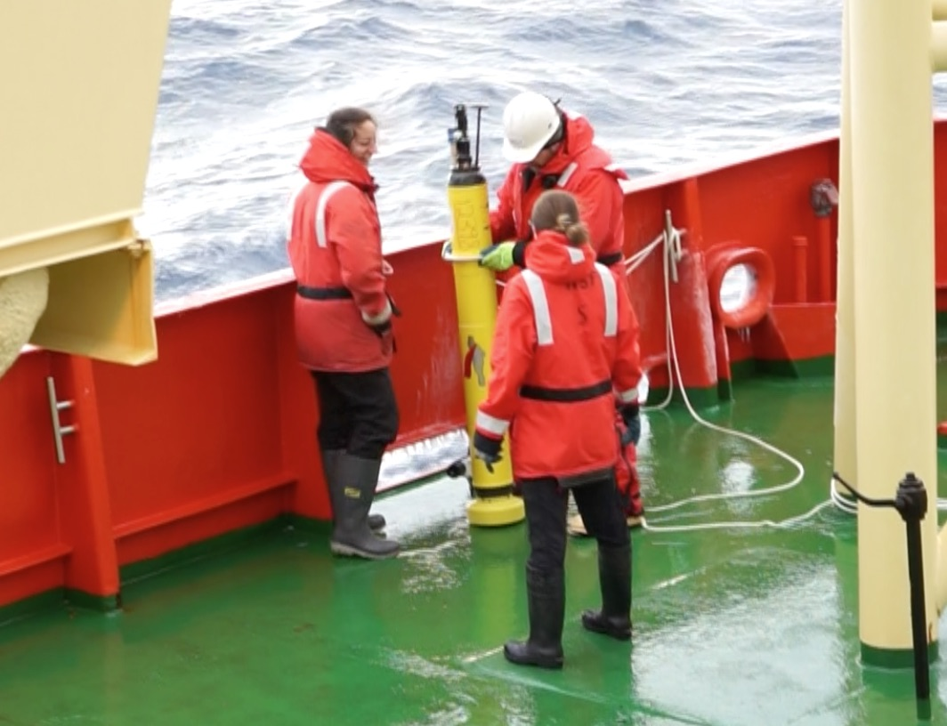

Deploying the Super Seal

A. Macdonald

Deploying the

Thunderbird-Martlet

March rushed to a close as we sampled along the western end of 67°S and watched the ice fill in our intended southernmost station positions on the 150°W line. We also began experiencing winch, or more accurately wire wrap, issues, which did not resolve in spite of good weather and fairly calm seas. We say issues, plural, because onboard and onshore experts are beginning to believe that more than one factor may be in play, but the net result has been long stations, interrupted by the need to periodically unwind and re-wind the wire on the drum.

We sought out a deep spot to carefully lower and rewind the wire, but we discovered two things: a) bathymetric features in the Southern Ocean are not always as they appear in the data base and b) carefully winding wire once would not guarantee it would wind up nicely the next time. So deciding that the best course of action was to remove the upper portion of the wire that was causing at least some of the trouble, and ever cognizant of growing ice to our south, we have decided to make a beeline for the start of 150°W line and use the transit time to cut the wire and re-terminate.

Students learning about and assisting in the re-termination.

(Photos by A. Macdonald)

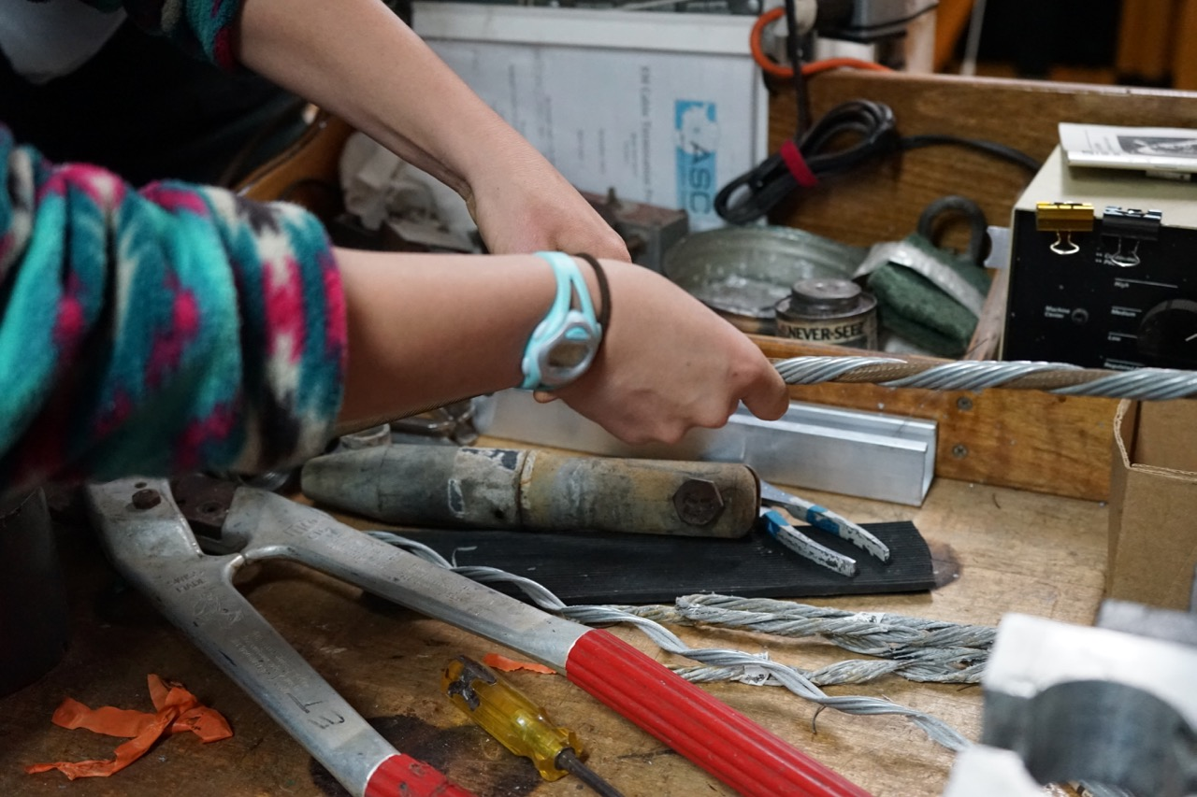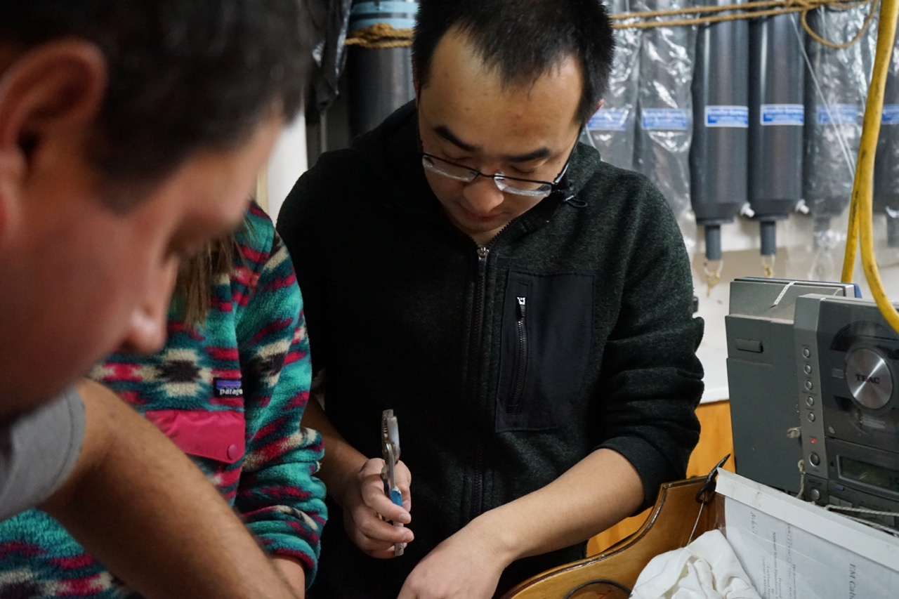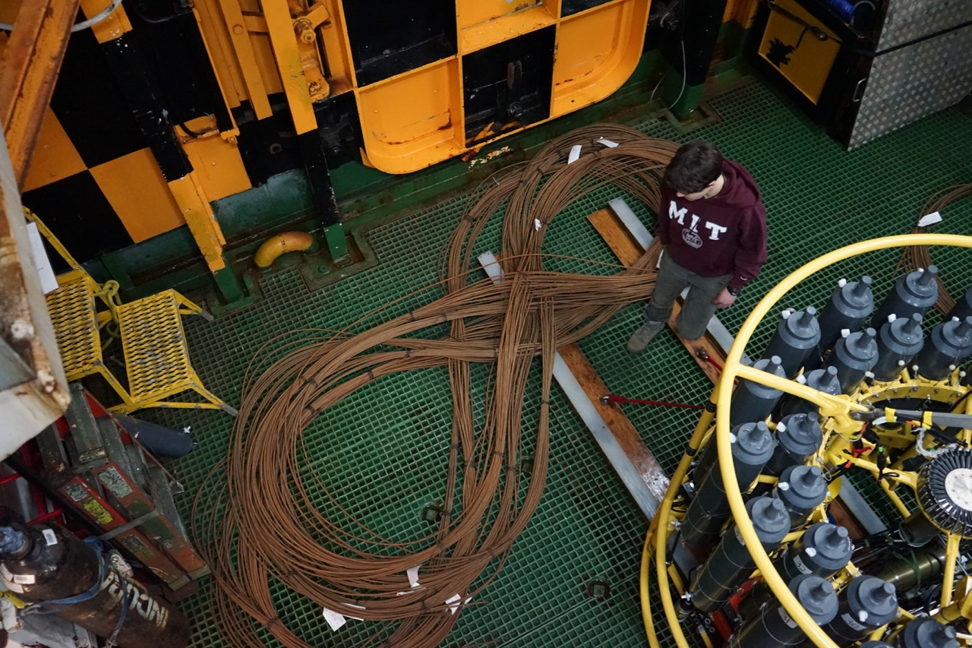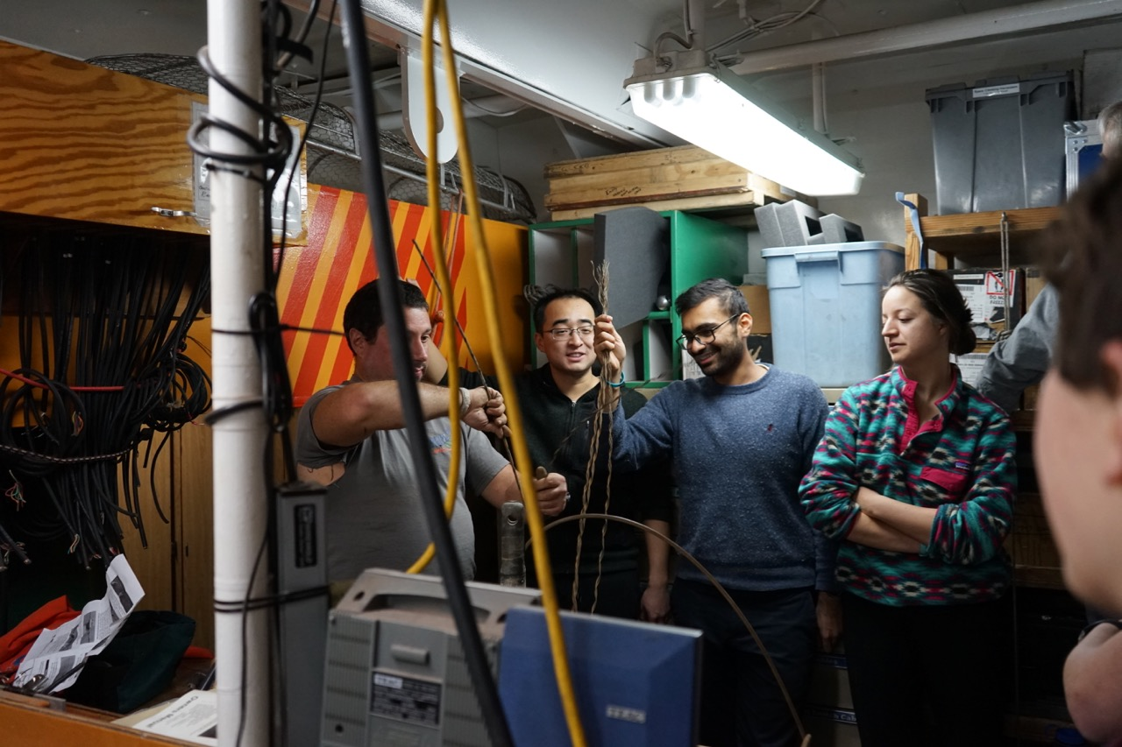

Lengths of cut wire

This decision was not impacted at all by the fact that we will have had 3 birthdays and a holiday before we arrive. The galley has been in almost non-stop chocolate cake production mode. Meanwhile, we are finding it difficult to stay away from the bridge, or even the bow (see temperatures shown above) for the chance of sighting of just one more amazing iceberg, a flock of animated penguins, a whale or two crossing our path or a seal basking in this white fluid wonderland of a landscape. Thus far, we have been blessed with excellent weather and ice conditions for the transit. We are making 8-10 knots breaking our way through new ice (click on speaker below to hear the sounds we make as crunch our way through surface ice such as that surrounding the iceberg – also shown below).

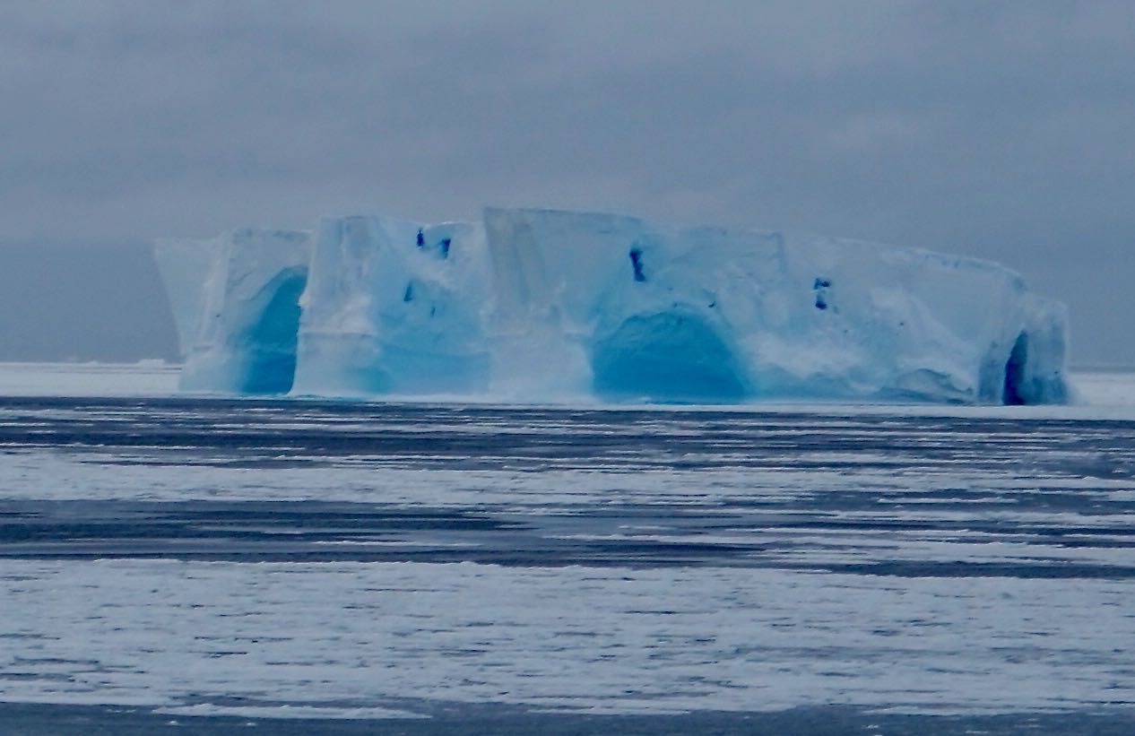

March 31, 2018

By M. Rintoul

It is hard not to enjoy the break. We are anticipating our attempt to make the shelf at 150°W with a growing sense of wonder at the beautiful chilled world around us. Nevertheless we are anticipating getting back to work too. We have already been at sea three weeks and making some serious headway on the many stations in our cruise plan is also on all our minds.

Until next week when we’ll tell you about a journey up the 150°W line,

Alison Macdonald (Chief Scientist)

Ellen Briggs (Co-chief Scientist)